Current Setup

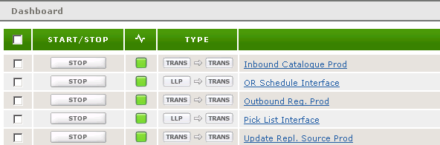

OR Schedule Interface LLP settings

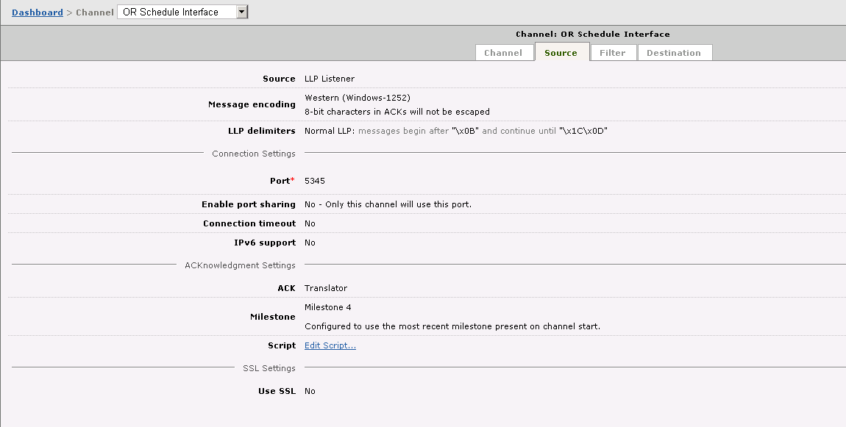

Pick List Interface LLP Settings

